1.Junit Basic Testing

Exercise 1: Setting Up Junit

Code:

package Test;
public class UnitTesting {
boolean checkEvenOdd(int num) {
if(num%2==0) return true;
return false;
}

}
Unit tests creation and output:
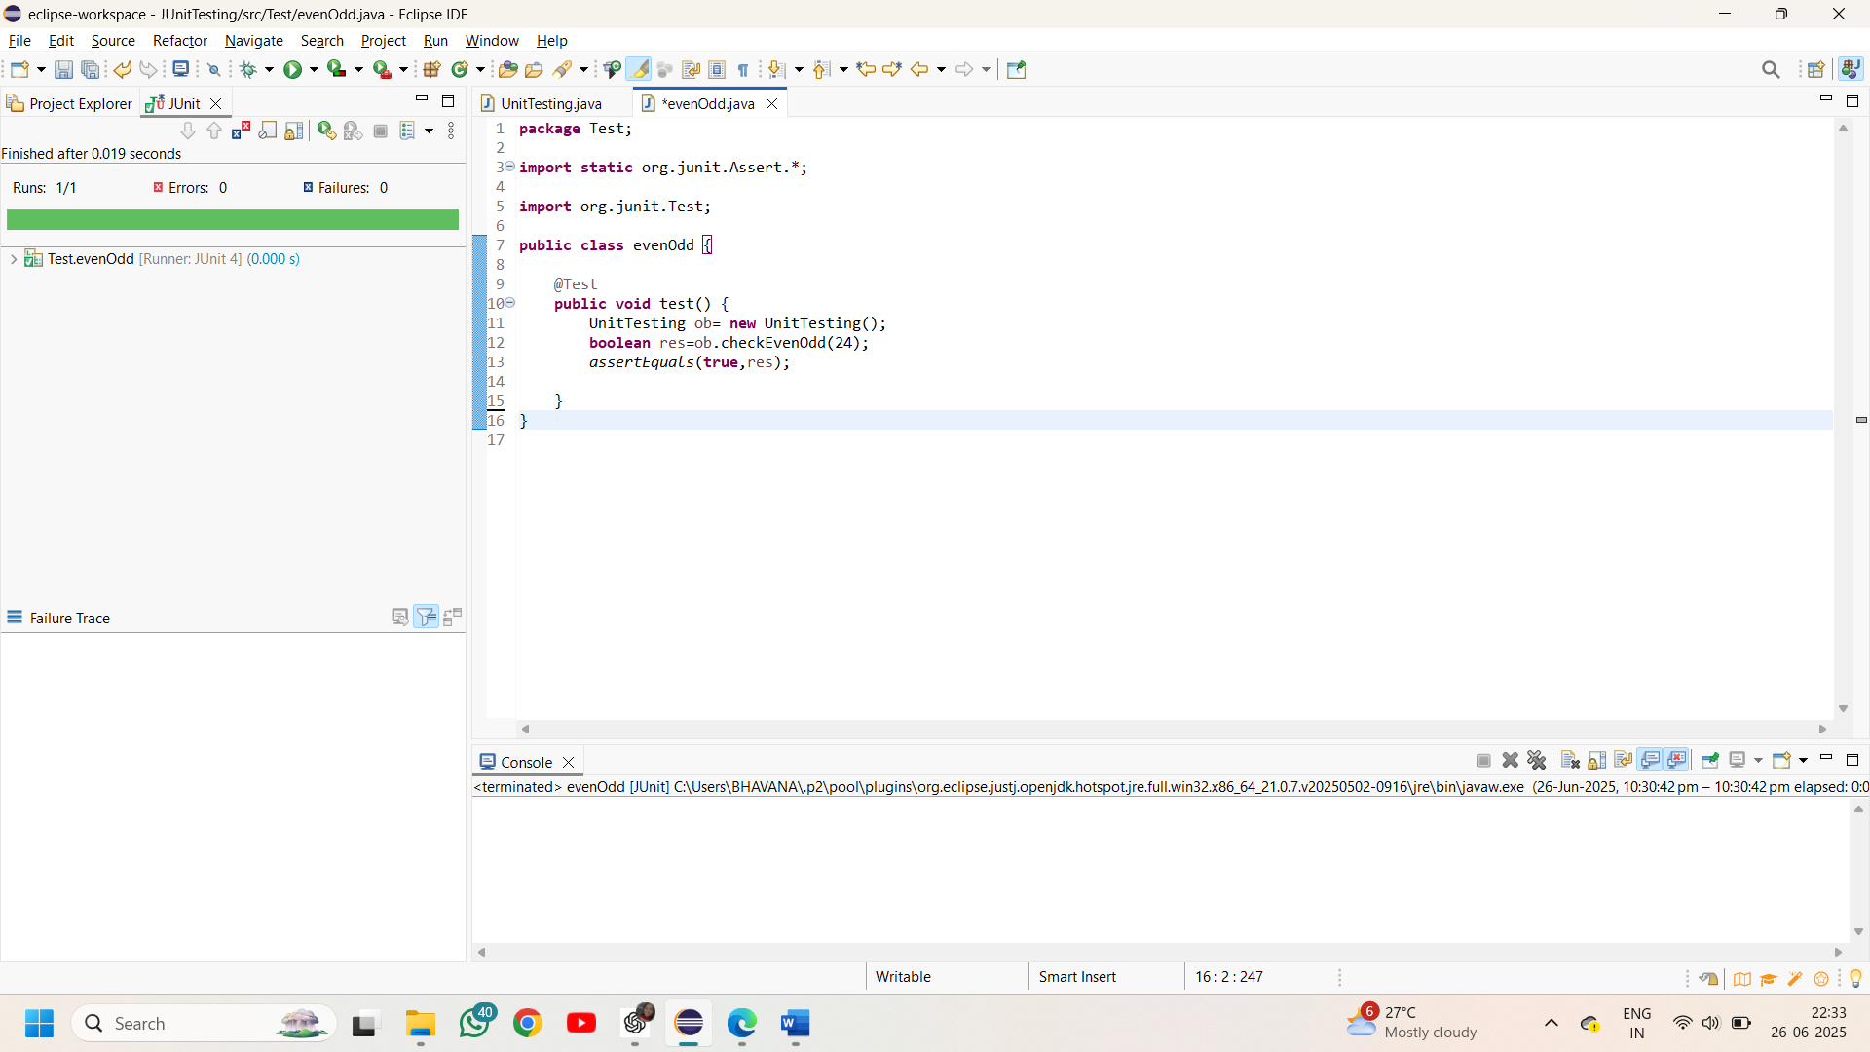

Exercise 2: Writing Basic JUnit Tests

Code:

package tests;
public class Calculate {
int add(int a,int b) {
return a+b;
}
int subtract(int a,int b) {
return a-b;
}
int multiply(int a,int b) {
return a*b;
}
int divide(int a,int b) {
if(b==0) throw new IllegalArgumentException("division is not possible");
return a/b;
}
}

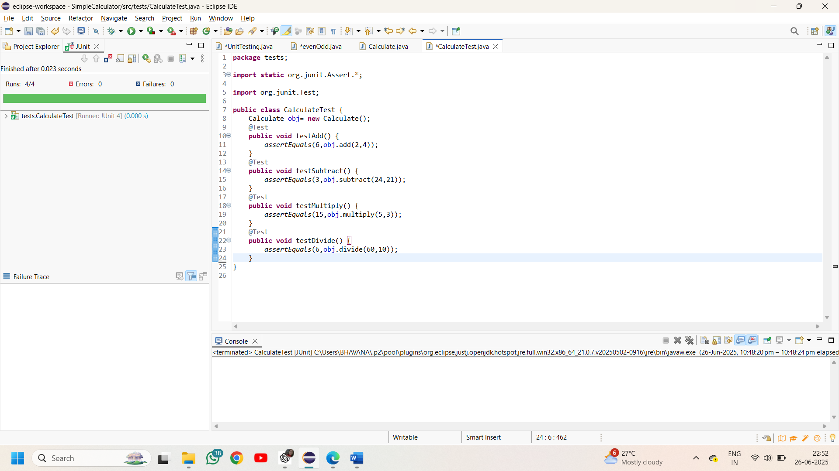
Junit tests and output:

Exercise 4:

Organization of tests using the Arrange-Act-Assert (AAA) pattern and setup, teardown methods.

package tests;
import static org.junit.Assert.*;
import org.junit.*;
public class AAA {
Calculate obj;
// generally before is to create object as it executes before every test
@Before
public void setUp() {
System.out.println("setting up..");
obj= new Calculate();
}
// after is used to clean up the memory
@After
public void tearDown() {
System.out.println("tearing down..");
obj=null;
}
@Test
public void AAA_pattern_add(){
int num1=30,num2=12; // arrange
int result=obj.add(30, 12); //act
assertEquals(42,result); //assert
}
@Test
public void AAA_pattern_subtract(){
int num1=76,num2=16; // arrange
int result=obj.subtract(76, 16); //act
assertEquals(60,result); //assert
}
}

